VolunteerSync
Evan Wilson
CST-452 Capstone Project Milestone 6: Final Project Completion
Grand Canyon University
Instructor: Professor Michael Landreth
Revision: 6.0

ABSTRACT

VolunteerSync is designed to be a responsive web application suitable for viewing on all screen sizes that simplifies how communities organize, discover, and complete volunteer opportunities. Organizers can register and be screened by an administrator to post events into a searchable catalog, set capacity, manage sign ups, and track participation. Volunteers can search for events using filters like date, location, organizer, or tags. They can sign up to volunteer at events, receive reminders, and build a verifiable record of all volunteering hours completed. After each event, organizers mark completion and attendance, which will trigger the generation of a signed certificate containing event details, hours, timestamp, and a unique certificate ID. A public verification page will be included to allow schools, employers, or scholarship programs to instantly confirm authenticity from the ID without having to interact with each organization directly.

The project will deliver an organizer dashboard with metrics and analytics, a volunteer dashboard with follows and notifications, certificate generation with online verification. The development stack uses Angular for the front end, a dedicated REST API, and MySQL database, and can be hosted in a variety of cloud providers to provide necessary scaling. Security controls include HTTPS, salted password hashing, JWT role claims for admin, organizer, and volunteer, parameterized queries, structured validation, and output encoding to help prevent SQL injection and XSS. Delivery uses seeded data generated with Mockaroo, automated tests, and GitHub Actions for build and test on each push, with a local staging environment for demos. VolunteerSync is an application open to all users regardless of religion while maintaining a positive Christian worldview by promoting service, emphasizing honest recordkeeping, and practicing ethical stewardship of user data.

History and Signoff Sheet
Change Record
Date | Author | Revision Notes
21SEP25 | Evan Wilson | Initial project proposal draft (Milestone 1) for review/discussion
12OCT25 | Evan Wilson | Milestone 2 Project Requirements submission
23NOV25 | Evan Wilson | Milestone 3 Development Phase 1
11JAN25 | Evan Wilson | Milestone 4 Development Phase 2
25JAN25 | Evan Wilson | Milestone 5 Testing

Overall Instructor Feedback/Comments
Milestone 1 (Project Proposal) Feedback:
Thank you for your work. Below are my main comments. Please keep in mind that I am looking at two key things: Did you fill all relevant sections needed per the milestone#1 and also per the rubric. Also is your work worth 20 weeks of work or not. Sometimes it is not easy to judge that early so I will just share my comments with you and you can elaborate more in your upcoming milestones to confirm that.
I like the idea although it may look simple but based on what you listed at the "challenges" section, I think this can be a good choice. Very important to keep the complexity manageable but also have stretch goal.

Milestone 2 Feedback:

You have developed a comprehensive and well-structured Requirements Analysis Document for VolunteerSync, showing clear understanding of both functional and technical aspects. Your use of detailed scope summaries for admins, organizers, and volunteers demonstrates careful consideration of all user roles and their interactions with the system. The technical requirements section is thorough, listing the full stack, testing tools, and CI/CD processes, which shows foresight into deployment and maintenance. Security measures are clearly articulated, including JWT role claims, password hashing, parameterized queries, and XSS mitigation, reflecting attention to protecting user data. You also provide practical planning for seed data and automated testing, demonstrating awareness of development best practices. The planned integrations, like email notifications and PDF generation, indicate thoughtful mapping of project features to user needs. Your report design is well-detailed, showing clear mapping of data to outputs for different roles. Overall, your document reflects a solid foundation for project implementation, with careful attention to functionality, security, and usability.
You could improve by elaborating more on exception handling and error recovery for both front-end and back-end processes. Expanding on performance and scalability requirements, such as expected concurrent users or load testing plans, would strengthen the NFR section. Additionally, providing more context on how ethical considerations and accessibility requirements are enforced could add depth to your system design rationale.
Milestone 3 Feedback:

Unavailable due to not having access to previous class anymore. However, there were no recommended changes to my plan or application at that time.

Milestone 4 Feedback:

Excellent

Milestone 5 Feedback:

Excellent!

Overall Instructor Feedback/Comments
Integrated Instructor Feedback into Project Documentation
☒ Yes ☐ No

TABLE OF CONTENTS
Design Overview 4
Detailed High-Level Solution Design 5
Detailed Technical Design 6
Appendix A – Technical Issue and Risk Log 7
Appendix B – References 8
Appendix C – External Resources 9

Design Introduction
- VolunteerSync is a web application that connects organizers with volunteers and provides verifiable records of service. The system has three primary roles, admin, organizer, and volunteer, plus a public verifier role for reading certificate authenticity. The front end is an Angular single page app that talks to a dedicated REST API. The API is organized into services for authentication, organizations, events, sign ups, certificates, notifications, and reporting. Data is stored in MySQL. Certificates are generated as PDFs with unique verification IDs. Email notifications are sent through an SMTP service for demo use, and key actions are written to an audit log. All traffic is secured with HTTPS in production, and the code uses JWT role claims, input validation, output encoding, and parameterized queries to reduce XSS and SQL injection risks.
The UI design includes wireframes for the home page, login and register, event search and details, organizer dashboard, and volunteer dashboard. High fidelity mockups are included as design references and are labeled as AI generated, the final code will be hand built in Angular. Process flows cover two key journeys, a volunteer signs up for an event, and an organizer marks attendance and issues a certificate that can later be verified by a third party. The logical architecture and a local-only physical deployment diagram are provided to show how the components fit together for the demo environment.

- Use the template to list the project deliverables that are to be included external to this Design Specification (Data Dictionary, API Design, etc.).
Deliverable Acceptance Log
ID | Deliverable Description | Comments | Evaluator (internal or external as applicable) | Status | Date of Decision
1 | Logical Architecture Diagram | Completed diagram showing major system components and interactions | Professor | Submitted | 12OCT25
2 | Physical Deployment Diagram (Local Environment) | Localhost configuration with Angular frontend, REST API, MySQL, SMTP, and log storage | Professor | Submitted | 12OCT25
3 | User Interface Diagrams (Wireframes & Mockups) | Includes low-fidelity wireframes and AI-generated design references | Professor | Submitted | 12OCT25
4 | Process Flow Diagrams | Volunteer signup and certificate verification workflows | Professor | Submitted | 12OCT25
5 | Service API Design Specification | REST endpoints, request/response formats, status codes, and error handling | Professor | Submitted | 09NOV25
6 | Expanded Entity Relationship Diagram (ERD) | Includes tables for users, organizations, events, signups, certificates, logs, notifications | Professor | Submitted | 09NOV25
7 | Data Dictionary | Table definitions, field types, constraints, and foreign keys | Professor | Submitted | 09NOV25
8 | Security and Non-Functional Design Section | Includes exception handling, authentication, backups, and performance expectations | Professor | Updated | 09NOV25
9 | Reports Design | Admin audit logs, volunteer service history, organizer metrics, CSV/PDF export | Professor | Submitted | 09NOV25

Detailed High-Level Solution Design
VolunteerSync is a three-tier web app. The Angular SPA calls a Node.js REST API that is organized into services for authentication, organizations, events, signups, certificates, notifications, reporting, and users. Data is stored in MySQL. Certificates are generated as PDFs with a unique verification ID. A public read only verification page allows third parties to confirm authenticity. Operational concerns include application logging, daily database backups, and a local SMTP relay for notifications. This design supports the core goals of connecting volunteers with opportunities, tracking hours, and issuing verifiable proof of service.

- Provide a detailed inventory of hardware and software technologies that will be used in the solution:

Proof of Concepts
Description | Rationale | Results
1 - JWT auth and role guard (Admin, Organizer, Volunteer) | Prove secure login, token issuance, and route protection before building features
2 - PDF certificate generation with verification ID | Validate creation of signed PDFs and stable, unique verification hash for public lookup
3 - Email notifications via local SMTP (NodeMailer + Ethereal) | Ensure reminders and certificate emails can be sent in dev without paid services
4 - MySQL backup and restore script (mysqldump) | Confirm daily snapshot and recovery path to meet reliability NFR
5 - Logging and error handling middleware | Standardize JSON error shape, log levels, and audit entries for key actions
6 - Indexed search and pagination for Events | Validate performance target for event search on seeded dat

Logical Solution Design:

The logical design of VolunteerSync shows how data and functions flow between the main layers of the system. The front end is built with Angular, which handles user interaction, role-based routing, and form validation. It communicates with a Node.js REST API that processes business logic, handles authentication, and connects to the MySQL database. Each service in the API is modular, supporting features like user management, event creation, signups, and certificate verification.
Data is stored in normalized MySQL tables with foreign keys enforcing relational integrity between users, organizations, events, and signups. Certificates are generated through the API and verified through a public endpoint. The architecture separates responsibilities clearly across tiers, improving maintainability and security.
This design meets non-functional requirements by emphasizing scalability, allowing future containerization or cloud deployment; security, using JWT authentication, hashed passwords, and validated input; and performance, through indexed queries and lightweight REST communication. Together, these support reliability, modular growth, and a secure user experience.

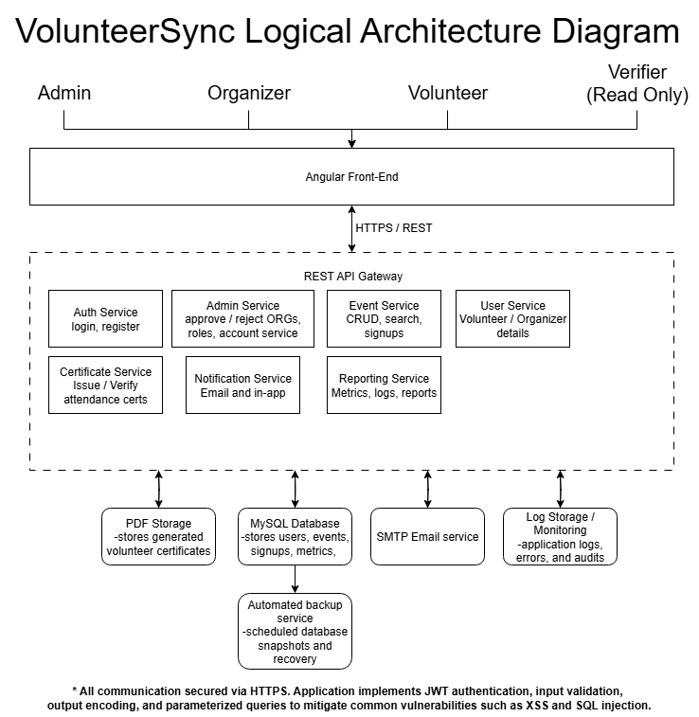
Physical Solution Design:

The physical architecture shows how VolunteerSync runs today during development and how it could scale later in a cloud deployment. In the local setup, Angular runs on localhost:4200 and talks to the Node.js API on localhost:8080, with MySQL running locally for persistence. MailHog handles test emails and certificates/logs are stored on the local file system. This setup keeps development fast and isolated while supporting early functional testing.
The future cloud deployment outlines how the system can meet non-functional requirements like scalability, availability, and security. The Angular front end would be deployed with static hosting behind a CDN. The Node API would run behind a load balancer with TLS termination, and MySQL would move to a managed service like Amazon RDS. Certificates and logs would be stored in secure cloud storage, and email would use SES or SendGrid. Cloud monitoring would improve reliability and traceability.

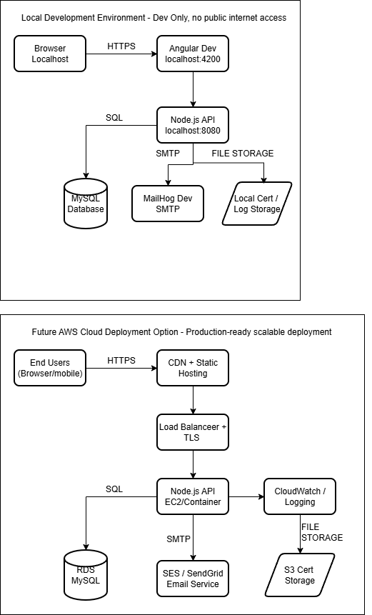

Detailed Technical Design
General Technical Approach:
VolunteerSync will be built as a three tier web application. The Angular front end provides a responsive UI for Admin, Organizer, Volunteer, and Verifier roles. The UI calls a Node.js Express REST API that contains modular services for authentication, organizations, events, signups, certificates, notifications, reporting, and users. Data is stored in MySQL with parameterized queries, input validation, and output encoding to reduce SQL injection and XSS risk. Authentication uses JWT with role claims. Certificates are generated as PDFs with a unique verification ID and a public verification endpoint. Email reminders and confirmations use a local SMTP relay during development. Logging captures key actions and errors, and a scheduled backup script creates daily database snapshots.
Process wise, I will work in short sprints that align with the course milestones. Each sprint will include requirements review, a small design slice, implementation, and tests. I will keep issues and tasks in the sprint backlog and track scope changes. Unit tests will cover core API endpoints and critical UI components. I will use GitHub branches and pull requests, with GitHub Actions running builds and tests on each push. Seed data from Mockaroo will support repeatable demos. Wireframes and AI mockups serve as visual references, final UI will be coded by hand in Angular.
Notes from planning and brainstorming to retain:
- Keep MVP tight: event discovery, signup, attendance, certificate, verification page
- Add dashboards for organizers and volunteers with simple charts and CSV export
- Use MailHog for email in development, no paid services
- Keep localization, forums, and AI recommendations as stretch items for CST-452
- Focus on clear error handling, accessible forms, and measurable performance targets

Key Technical Design Decisions:

Technology / Decision | Purpose in the Design | Why Chosen and Validation
Angular (LTS) | SPA front end, routing, reusable UI components, form handling | Strong CLI support, built-in unit testing, scalable modular architecture. Previously used in coursework.
Node.js + Express | REST API backend, request routing, middleware support | Simple to implement, large community, ideal for REST microservices. Used in earlier VolunteerSync version.
MySQL | Persistent relational data storage | Good for structured event/volunteer schema, widely supported, easy local setup.
mysql2 driver | Secure database queries | Supports prepared statements to prevent SQL injection. Lightweight and reliable.
JWT + bcrypt | Authentication and role-based authorization | Stateless token-based auth fits SPA architecture. Tested and validated in prior implementation.
JSPDF | PDF certificate generation | Supports dynamic certificate layouts and file streaming. Good long-term flexibility.
NodeMailer + Ethereal | Email sending in development | Enables local testing without third-party cost. Validated with simple POC email delivery.
Jasmine + Karma | Frontend unit testing | Built into Angular, fast test execution, easy component mocking.
Jest + Supertest | Backend API testing | Excellent coverage for route-level testing and response validation.
Winston Logger | Logging, audit trail, and error tracking | Industry standard Node logger. Enables formatted logs and file rotation.
Mockaroo | Test and seed data generation | Generates realistic randomized datasets for testing database logic.
GitHub + GitHub Actions | Source control, CI pipeline | Automates builds and test runs on each push. Improves development quality.
IntelliJ IDEA / VS Code | IDEs for development | IntelliJ supports full-stack workflows. VS Code used for lightweight Angular development.
MySQL Workbench | Database design and ER modeling | Used for schema visualization and query debugging.
Postman | Manual REST API testing | Useful for debugging endpoints and testing authentication tokens.
Draw.io (diagrams.net) | Architecture and UML diagrams | Free tool, easy to export professional diagrams for documentation.

Database ER Diagram:

The Entity-Relationship Diagram (ERD) represents the logical data model for the VolunteerSync platform. The database is designed to support core application functionality including user management, event scheduling, volunteer participation, certificate generation, and system notifications. The schema follows a normalized relational structure to ensure data consistency, maintainability, and scalability.
The users table stores account information for all roles (volunteer, organizer, and admin). User accounts may be optionally associated with an organization, and role-based access is enforced at the application level. The organizations table manages details about organizations that post volunteer events, including approval tracking handled by the admin role.
Volunteer opportunities are stored in the events table, and participation is managed through the signups table, which maintains a unique record for each user who registers for an event. The event_attendance table tracks attendance verification and logs valid service hours.
To support searchable categorization, events can be tagged using a many-to-many relationship implemented via the event_tags join table and the tags lookup table. Volunteers may follow organizations or event tags through the user_follow_organizations and user_follow_tags tables to receive relevant updates.
The certificates table issues verifiable digital service certificates with unique verification IDs for each user based on event completion. Notifications such as reminders and confirmations are managed through the notifications table, allowing scheduled and targeted communication.
Overall, the ERD reflects a modular and extensible data model designed to support future enhancements while maintaining referential integrity through appropriate use of foreign keys and cascading rules.
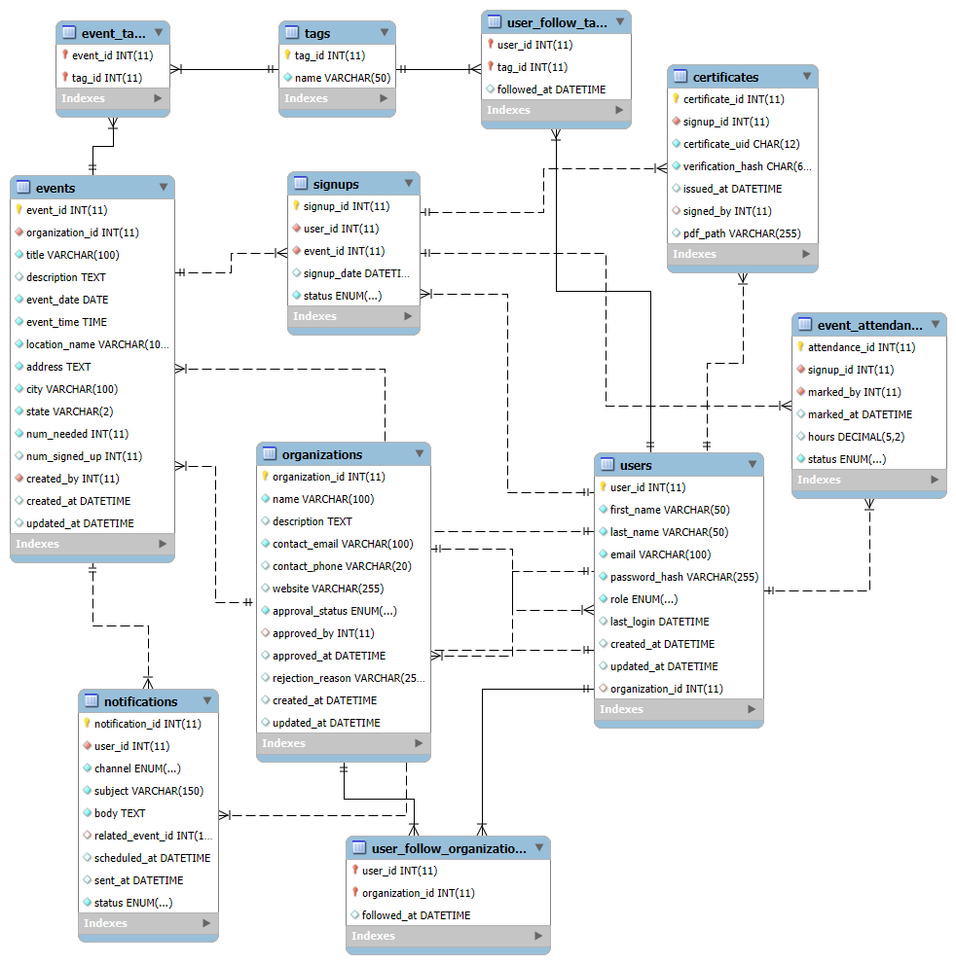

Database DDL Scripts:

SET @OLD_UNIQUE_CHECKS=@@UNIQUE_CHECKS, UNIQUE_CHECKS=0;
SET @OLD_FOREIGN_KEY_CHECKS=@@FOREIGN_KEY_CHECKS, FOREIGN_KEY_CHECKS=0;
SET @OLD_SQL_MODE=@@SQL_MODE, SQL_MODE='ONLY_FULL_GROUP_BY,STRICT_TRANS_TABLES,NO_ZERO_IN_DATE,NO_ZERO_DATE,ERROR_FOR_DIVISION_BY_ZERO,NO_ENGINE_SUBSTITUTION';

-- -----------------------------------------------------
-- Schema mydb
-- -----------------------------------------------------
-- -----------------------------------------------------
-- Schema volunteersync
-- -----------------------------------------------------

-- -----------------------------------------------------
-- Schema volunteersync
-- -----------------------------------------------------
CREATE SCHEMA IF NOT EXISTS `volunteersync` DEFAULT CHARACTER SET utf8 ;
USE `volunteersync` ;

-- -----------------------------------------------------
-- Table `volunteersync`.`organizations`
-- -----------------------------------------------------
CREATE TABLE IF NOT EXISTS `volunteersync`.`organizations` (
`organization_id` INT(11) NOT NULL AUTO_INCREMENT,
`name` VARCHAR(100) NOT NULL,
`description` TEXT NULL DEFAULT NULL,
`contact_email` VARCHAR(100) NOT NULL,
`contact_phone` VARCHAR(20) NULL DEFAULT NULL,
`website` VARCHAR(255) NULL DEFAULT NULL,
`approval_status` ENUM('pending', 'approved', 'rejected') NOT NULL DEFAULT 'pending',
`approved_by` INT(11) NULL DEFAULT NULL,
`approved_at` DATETIME NULL DEFAULT NULL,
`rejection_reason` VARCHAR(255) NULL DEFAULT NULL,
`created_at` DATETIME NULL DEFAULT CURRENT_TIMESTAMP,
`updated_at` DATETIME NULL DEFAULT CURRENT_TIMESTAMP ON UPDATE CURRENT_TIMESTAMP,
PRIMARY KEY (`organization_id`),
UNIQUE INDEX `unique_organization_name` (`name` ASC),
INDEX `idx_org_approval` (`approval_status` ASC, `approved_at` ASC),
INDEX `fk_org_approved_by` (`approved_by` ASC),
CONSTRAINT `fk_org_approved_by`
FOREIGN KEY (`approved_by`)
REFERENCES `volunteersync`.`users` (`user_id`)
ON DELETE SET NULL)
ENGINE = InnoDB
AUTO_INCREMENT = 12
DEFAULT CHARACTER SET = utf8;

-- -----------------------------------------------------
-- Table `volunteersync`.`users`
-- -----------------------------------------------------
CREATE TABLE IF NOT EXISTS `volunteersync`.`users` (
`user_id` INT(11) NOT NULL AUTO_INCREMENT,
`first_name` VARCHAR(50) NOT NULL,
`last_name` VARCHAR(50) NOT NULL,
`email` VARCHAR(100) NOT NULL,
`password_hash` VARCHAR(255) NOT NULL,
`role` ENUM('volunteer', 'organizer', 'admin') NOT NULL,
`last_login` DATETIME NULL DEFAULT NULL,
`created_at` DATETIME NULL DEFAULT CURRENT_TIMESTAMP,
`updated_at` DATETIME NULL DEFAULT CURRENT_TIMESTAMP ON UPDATE CURRENT_TIMESTAMP,
`organization_id` INT(11) NULL DEFAULT NULL,
PRIMARY KEY (`user_id`),
UNIQUE INDEX `email` (`email` ASC),
UNIQUE INDEX `unique_user_email` (`email` ASC),
INDEX `fk_user_organization` (`organization_id` ASC),
CONSTRAINT `fk_user_organization`
FOREIGN KEY (`organization_id`)
REFERENCES `volunteersync`.`organizations` (`organization_id`)
ON DELETE SET NULL)
ENGINE = InnoDB
AUTO_INCREMENT = 15
DEFAULT CHARACTER SET = utf8;

-- -----------------------------------------------------
-- Table `volunteersync`.`events`
-- -----------------------------------------------------
CREATE TABLE IF NOT EXISTS `volunteersync`.`events` (
`event_id` INT(11) NOT NULL AUTO_INCREMENT,
`organization_id` INT(11) NOT NULL,
`title` VARCHAR(100) NOT NULL,
`description` TEXT NULL DEFAULT NULL,
`event_date` DATE NOT NULL,
`event_time` TIME NOT NULL,
`location_name` VARCHAR(100) NOT NULL,
`address` TEXT NOT NULL,
`city` VARCHAR(100) NOT NULL,
`state` VARCHAR(2) NOT NULL,
`num_needed` INT(11) NOT NULL,
`num_signed_up` INT(11) NULL DEFAULT '0',
`created_by` INT(11) NOT NULL,
`created_at` DATETIME NULL DEFAULT CURRENT_TIMESTAMP,
`updated_at` DATETIME NULL DEFAULT CURRENT_TIMESTAMP ON UPDATE CURRENT_TIMESTAMP,
PRIMARY KEY (`event_id`),
UNIQUE INDEX `unique_event_constraint` (`organization_id` ASC, `event_date` ASC, `event_time` ASC, `location_name` ASC, `title` ASC),
INDEX `created_by` (`created_by` ASC),
INDEX `idx_event_city_state` (`city` ASC, `state` ASC),
INDEX `idx_event_date` (`event_date` ASC),
INDEX `idx_event_org` (`organization_id` ASC),
INDEX `idx_org_date` (`organization_id` ASC, `event_date` ASC),
INDEX `idx_city_state_date` (`city` ASC, `state` ASC, `event_date` ASC),
CONSTRAINT `events_ibfk_1`
FOREIGN KEY (`organization_id`)
REFERENCES `volunteersync`.`organizations` (`organization_id`)
ON DELETE CASCADE,
CONSTRAINT `events_ibfk_2`
FOREIGN KEY (`created_by`)
REFERENCES `volunteersync`.`users` (`user_id`)
ON DELETE CASCADE)
ENGINE = InnoDB
AUTO_INCREMENT = 17
DEFAULT CHARACTER SET = utf8;

-- -----------------------------------------------------
-- Table `volunteersync`.`signups`
-- -----------------------------------------------------
CREATE TABLE IF NOT EXISTS `volunteersync`.`signups` (
`signup_id` INT(11) NOT NULL AUTO_INCREMENT,
`user_id` INT(11) NOT NULL,
`event_id` INT(11) NOT NULL,
`signup_date` DATETIME NULL DEFAULT CURRENT_TIMESTAMP,
`status` ENUM('registered', 'canceled') NOT NULL DEFAULT 'registered',
PRIMARY KEY (`signup_id`),
UNIQUE INDEX `unique_user_event` (`user_id` ASC, `event_id` ASC),
INDEX `event_id` (`event_id` ASC),
CONSTRAINT `signups_ibfk_1`
FOREIGN KEY (`user_id`)
REFERENCES `volunteersync`.`users` (`user_id`)
ON DELETE CASCADE,
CONSTRAINT `signups_ibfk_2`
FOREIGN KEY (`event_id`)
REFERENCES `volunteersync`.`events` (`event_id`)
ON DELETE CASCADE)
ENGINE = InnoDB
AUTO_INCREMENT = 16
DEFAULT CHARACTER SET = utf8;

-- -----------------------------------------------------
-- Table `volunteersync`.`certificates`
-- -----------------------------------------------------
CREATE TABLE IF NOT EXISTS `volunteersync`.`certificates` (
`certificate_id` INT(11) NOT NULL AUTO_INCREMENT,
`signup_id` INT(11) NOT NULL,
`certificate_uid` CHAR(12) NOT NULL,
`verification_hash` CHAR(64) NOT NULL,
`issued_at` DATETIME NULL DEFAULT CURRENT_TIMESTAMP,
`signed_by` INT(11) NULL DEFAULT NULL,
`pdf_path` VARCHAR(255) NULL DEFAULT NULL,
PRIMARY KEY (`certificate_id`),
UNIQUE INDEX `uniq_cert_signup` (`signup_id` ASC),
UNIQUE INDEX `uniq_cert_uid` (`certificate_uid` ASC),
UNIQUE INDEX `uniq_cert_hash` (`verification_hash` ASC),
INDEX `idx_signed_by` (`signed_by` ASC),
CONSTRAINT `fk_cert_signed_by`
FOREIGN KEY (`signed_by`)
REFERENCES `volunteersync`.`users` (`user_id`)
ON DELETE SET NULL,
CONSTRAINT `fk_cert_signup`
FOREIGN KEY (`signup_id`)
REFERENCES `volunteersync`.`signups` (`signup_id`)
ON DELETE CASCADE)
ENGINE = InnoDB
DEFAULT CHARACTER SET = utf8;

-- -----------------------------------------------------
-- Table `volunteersync`.`event_attendance`
-- -----------------------------------------------------
CREATE TABLE IF NOT EXISTS `volunteersync`.`event_attendance` (
`attendance_id` INT(11) NOT NULL AUTO_INCREMENT,
`signup_id` INT(11) NOT NULL,
`marked_by` INT(11) NOT NULL,
`marked_at` DATETIME NULL DEFAULT CURRENT_TIMESTAMP,
`hours` DECIMAL(5,2) NULL DEFAULT NULL,
`status` ENUM('completed', 'no_show', 'excused') NOT NULL DEFAULT 'completed',
PRIMARY KEY (`attendance_id`),
UNIQUE INDEX `uniq_signup_attendance` (`signup_id` ASC),
INDEX `idx_marked_by` (`marked_by` ASC),
CONSTRAINT `fk_attendance_markedby`
FOREIGN KEY (`marked_by`)
REFERENCES `volunteersync`.`users` (`user_id`),
CONSTRAINT `fk_attendance_signup`
FOREIGN KEY (`signup_id`)
REFERENCES `volunteersync`.`signups` (`signup_id`)
ON DELETE CASCADE)
ENGINE = InnoDB
DEFAULT CHARACTER SET = utf8;

-- -----------------------------------------------------
-- Table `volunteersync`.`tags`
-- -----------------------------------------------------
CREATE TABLE IF NOT EXISTS `volunteersync`.`tags` (
`tag_id` INT(11) NOT NULL AUTO_INCREMENT,
`name` VARCHAR(50) NOT NULL,
PRIMARY KEY (`tag_id`),
UNIQUE INDEX `uniq_tag_name` (`name` ASC))
ENGINE = InnoDB
DEFAULT CHARACTER SET = utf8;

-- -----------------------------------------------------
-- Table `volunteersync`.`event_tags`
-- -----------------------------------------------------
CREATE TABLE IF NOT EXISTS `volunteersync`.`event_tags` (
`event_id` INT(11) NOT NULL,
`tag_id` INT(11) NOT NULL,
PRIMARY KEY (`event_id`, `tag_id`),
INDEX `idx_tag_event` (`tag_id` ASC),
CONSTRAINT `fk_et_event`
FOREIGN KEY (`event_id`)
REFERENCES `volunteersync`.`events` (`event_id`)
ON DELETE CASCADE,
CONSTRAINT `fk_et_tag`
FOREIGN KEY (`tag_id`)
REFERENCES `volunteersync`.`tags` (`tag_id`)
ON DELETE CASCADE)
ENGINE = InnoDB
DEFAULT CHARACTER SET = utf8;

-- -----------------------------------------------------
-- Table `volunteersync`.`notifications`
-- -----------------------------------------------------
CREATE TABLE IF NOT EXISTS `volunteersync`.`notifications` (
`notification_id` INT(11) NOT NULL AUTO_INCREMENT,
`user_id` INT(11) NOT NULL,
`channel` ENUM('email', 'in_app') NOT NULL DEFAULT 'email',
`subject` VARCHAR(150) NOT NULL,
`body` TEXT NOT NULL,
`related_event_id` INT(11) NULL DEFAULT NULL,
`scheduled_at` DATETIME NULL DEFAULT NULL,
`sent_at` DATETIME NULL DEFAULT NULL,
`status` ENUM('pending', 'sent', 'failed') NOT NULL DEFAULT 'pending',
PRIMARY KEY (`notification_id`),
INDEX `idx_notif_user` (`user_id` ASC),
INDEX `idx_notif_event` (`related_event_id` ASC),
INDEX `idx_notif_status` (`status` ASC),
CONSTRAINT `fk_notif_event`
FOREIGN KEY (`related_event_id`)
REFERENCES `volunteersync`.`events` (`event_id`)
ON DELETE SET NULL,
CONSTRAINT `fk_notif_user`
FOREIGN KEY (`user_id`)
REFERENCES `volunteersync`.`users` (`user_id`)
ON DELETE CASCADE)
ENGINE = InnoDB
DEFAULT CHARACTER SET = utf8;

-- -----------------------------------------------------
-- Table `volunteersync`.`user_follow_organizations`
-- -----------------------------------------------------
CREATE TABLE IF NOT EXISTS `volunteersync`.`user_follow_organizations` (
`user_id` INT(11) NOT NULL,
`organization_id` INT(11) NOT NULL,
`followed_at` DATETIME NULL DEFAULT CURRENT_TIMESTAMP,
PRIMARY KEY (`user_id`, `organization_id`),
INDEX `idx_ufo_org` (`organization_id` ASC),
CONSTRAINT `fk_ufo_org`
FOREIGN KEY (`organization_id`)
REFERENCES `volunteersync`.`organizations` (`organization_id`)
ON DELETE CASCADE,
CONSTRAINT `fk_ufo_user`
FOREIGN KEY (`user_id`)
REFERENCES `volunteersync`.`users` (`user_id`)
ON DELETE CASCADE)
ENGINE = InnoDB
DEFAULT CHARACTER SET = utf8;

-- -----------------------------------------------------
-- Table `volunteersync`.`user_follow_tags`
-- -----------------------------------------------------
CREATE TABLE IF NOT EXISTS `volunteersync`.`user_follow_tags` (
`user_id` INT(11) NOT NULL,
`tag_id` INT(11) NOT NULL,
`followed_at` DATETIME NULL DEFAULT CURRENT_TIMESTAMP,
PRIMARY KEY (`user_id`, `tag_id`),
INDEX `idx_uft_tag` (`tag_id` ASC),
CONSTRAINT `fk_uft_tag`
FOREIGN KEY (`tag_id`)
REFERENCES `volunteersync`.`tags` (`tag_id`)
ON DELETE CASCADE,
CONSTRAINT `fk_uft_user`
FOREIGN KEY (`user_id`)
REFERENCES `volunteersync`.`users` (`user_id`)
ON DELETE CASCADE)
ENGINE = InnoDB
DEFAULT CHARACTER SET = utf8;

SET SQL_MODE=@OLD_SQL_MODE;
SET FOREIGN_KEY_CHECKS=@OLD_FOREIGN_KEY_CHECKS;
SET UNIQUE_CHECKS=@OLD_UNIQUE_CHECKS;
Flow Charts/Process Flows:

Sitemap Diagram:

The site map below represents the planned navigation structure for the VolunteerSync web application. It outlines the main pages accessible to users, the role-based access flow, and how users interact with available features based on authentication and authorization.
The top-level navigation includes publicly accessible pages such as Home, Events, Organizations, Login, Register, Verify Certificates, and Support/Contact. These pages establish the core entry points for users who are browsing the platform or creating an account.
Subpages allow users to drill into content. For example, selecting an event from the event list leads to the Event Details page, and users can proceed to Volunteer Signup from there after authentication. Similarly, selecting an organization directs users to the View Organization page for additional information.
Once authenticated, users are granted role-based access that determines what sections of the site they can interact with:
- Volunteers have access to My Events and My Certificates, which display registered events and certificates earned.
- Organizers access an Organizer Dashboard, where they can Manage Events and handle Attendance Confirmation for volunteers.
- Admins have elevated access via the Admin Dashboard, where they can Manage Users, Manage Organizations, and review System Logs / Reports.
Error and system exception pages (401 Unauthorized, 404 Not Found, and 500 Server Error) are included but are not part of normal navigation routes; they are triggered only when specific application conditions occur.
This sitemap defines a consistent, role-aware structure that improves usability while supporting secure navigation. It also ensures scalability as new features (such as dashboards, reporting pages, and certificate verification) are clearly organized without disrupting the core navigation experience.

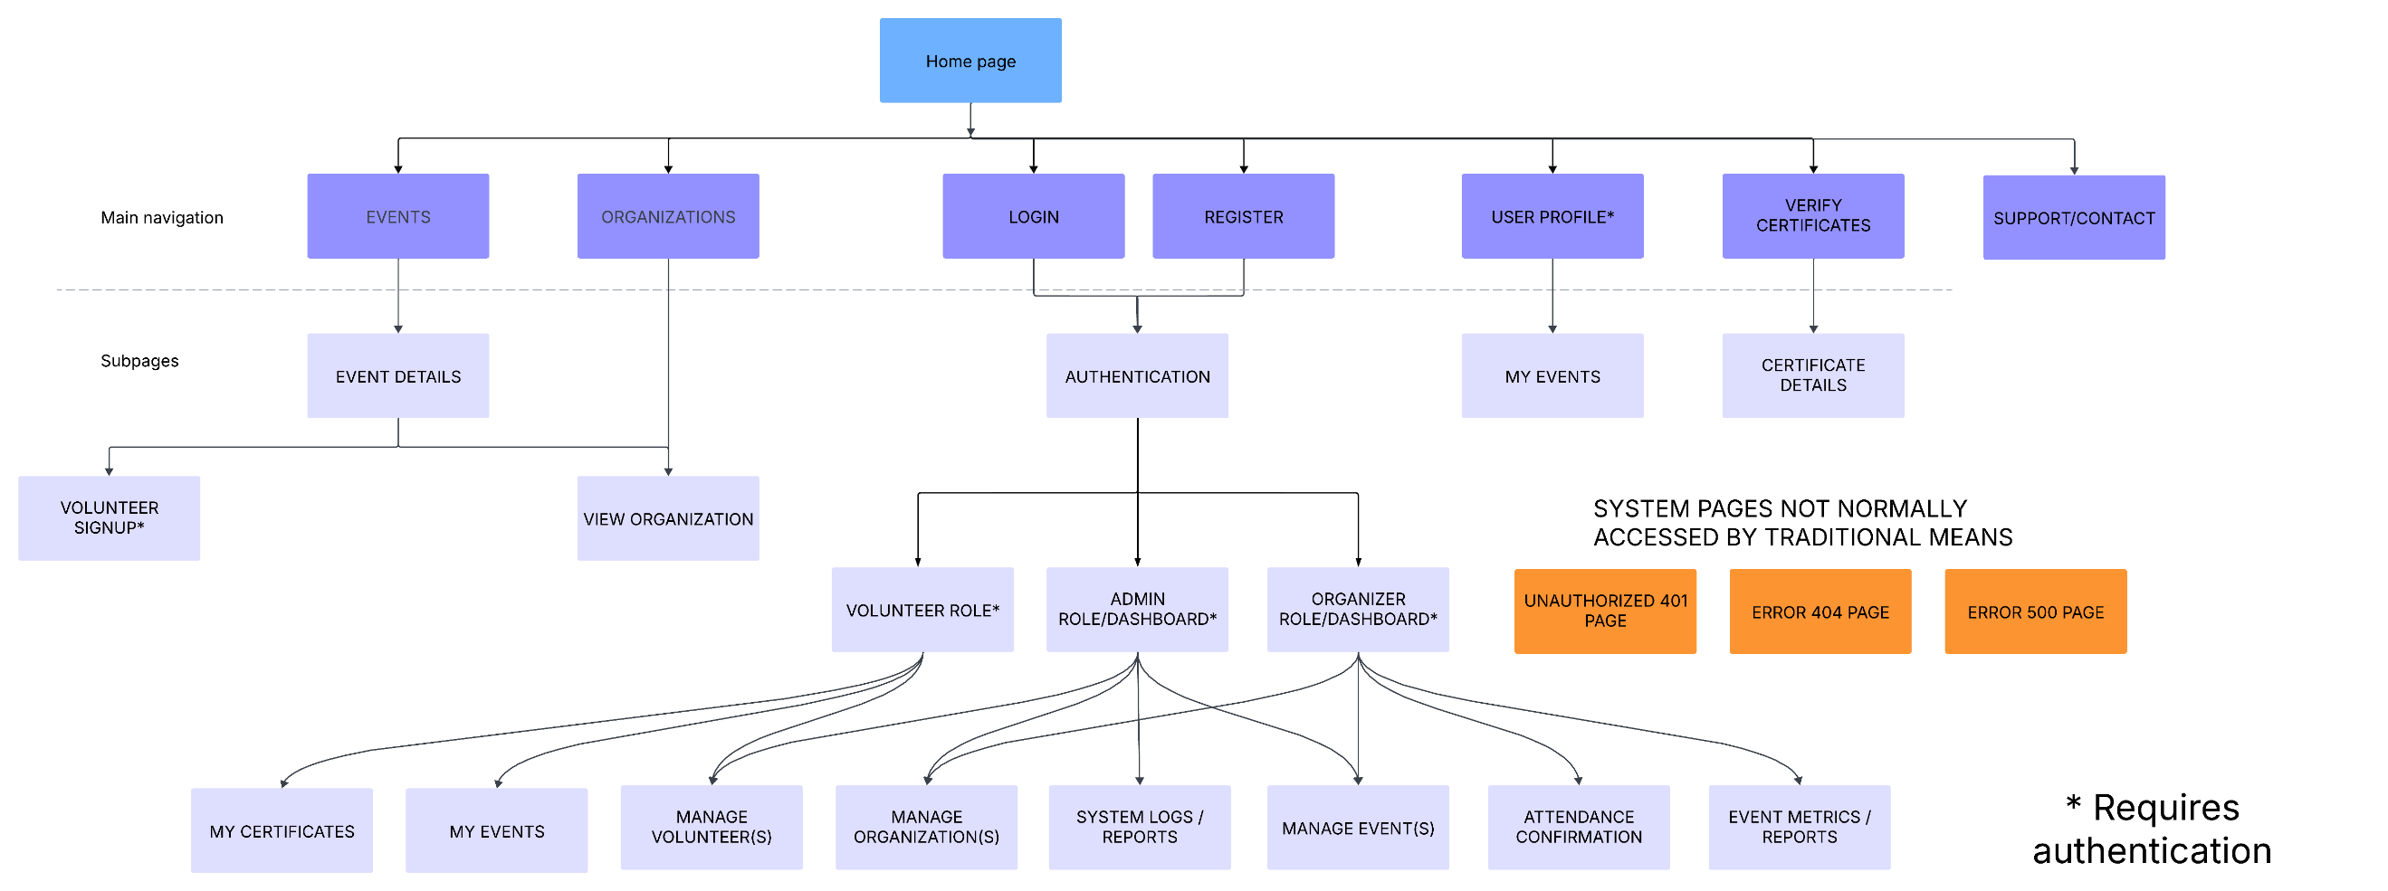

User Interface /Wireframes Diagrams:
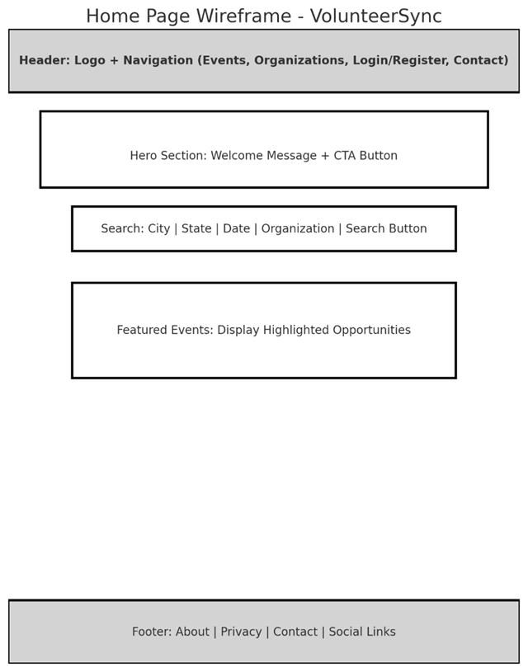

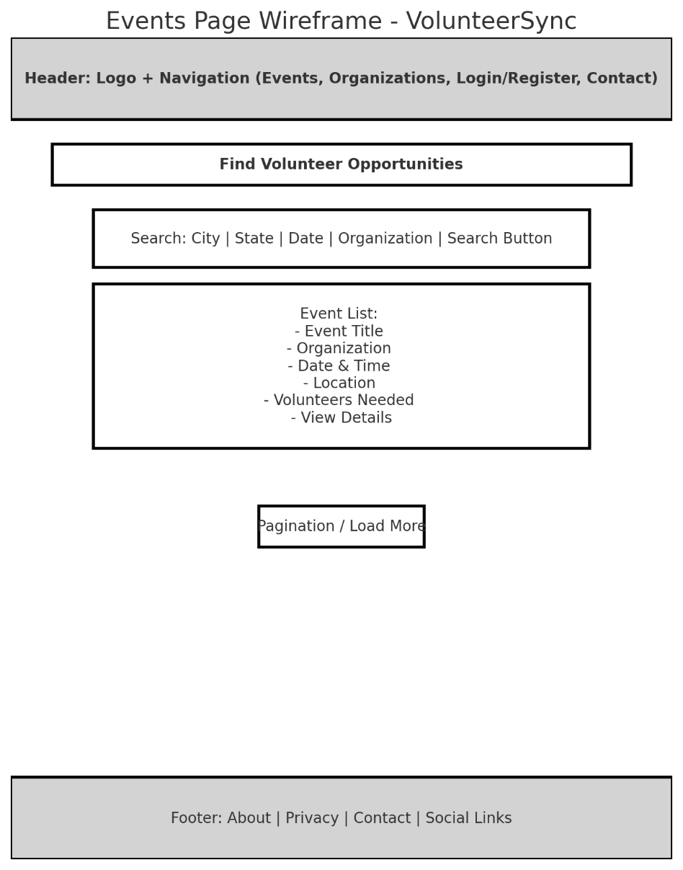
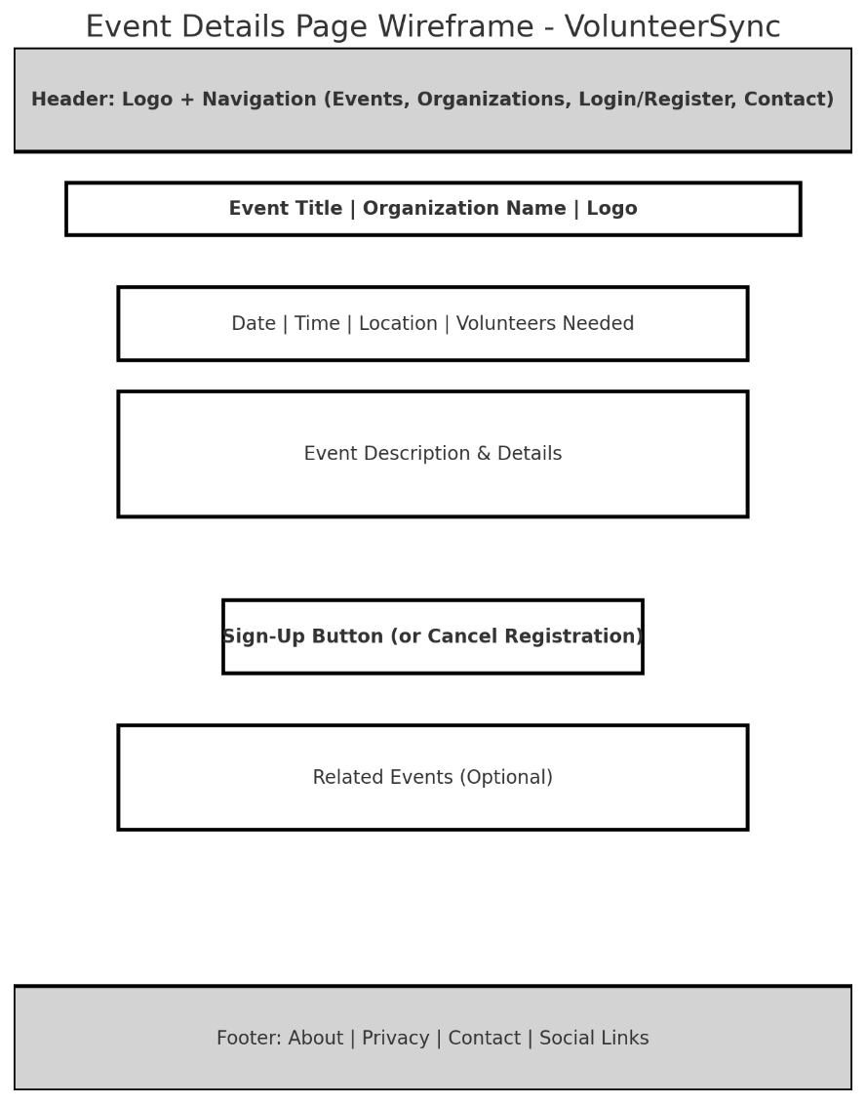
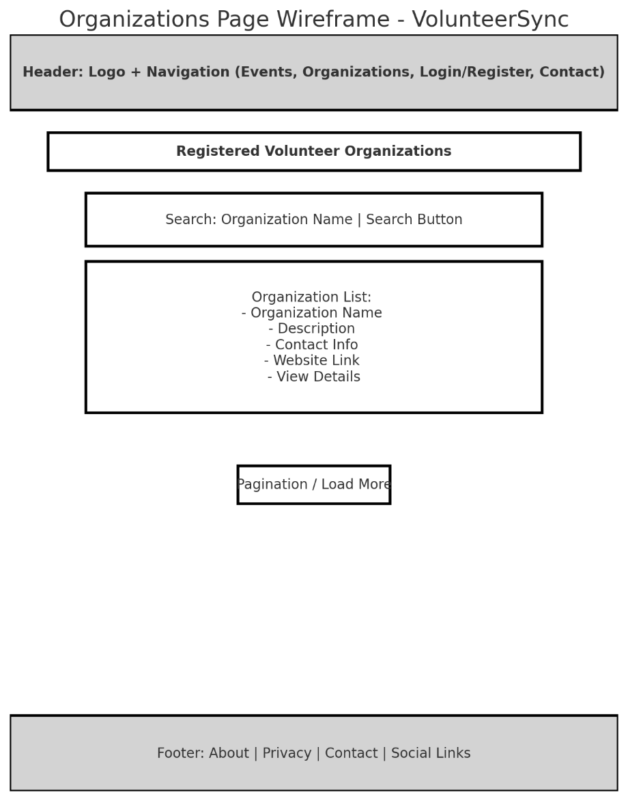
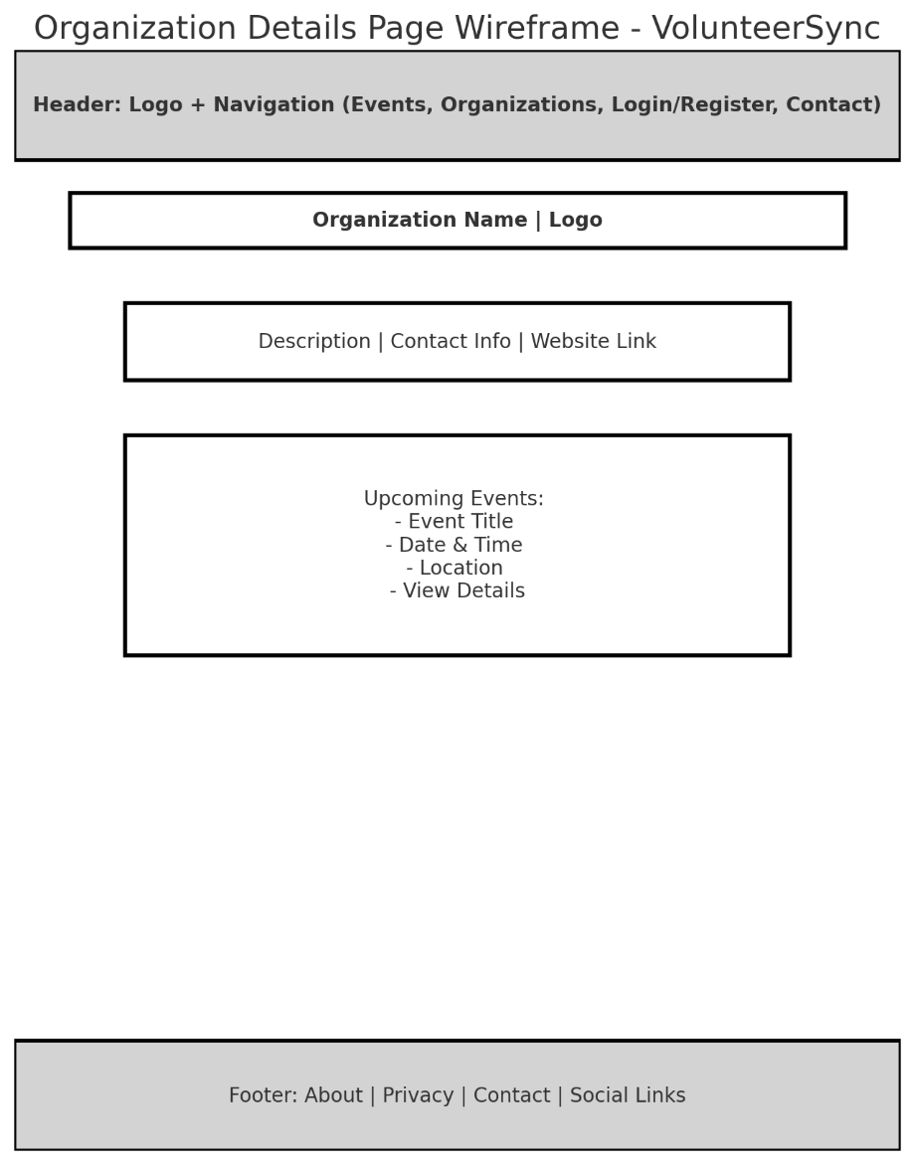
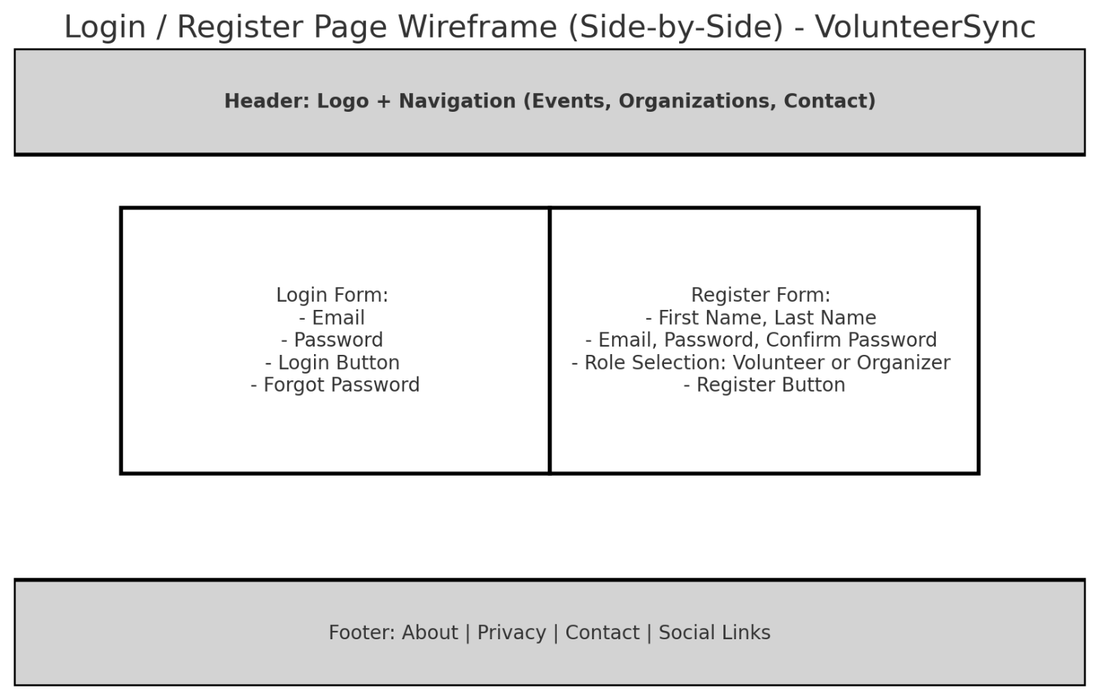
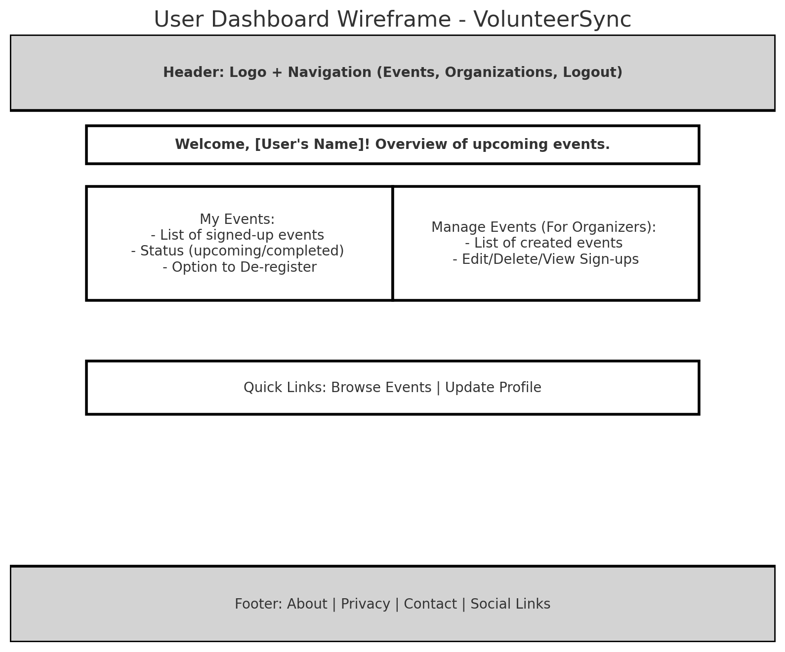
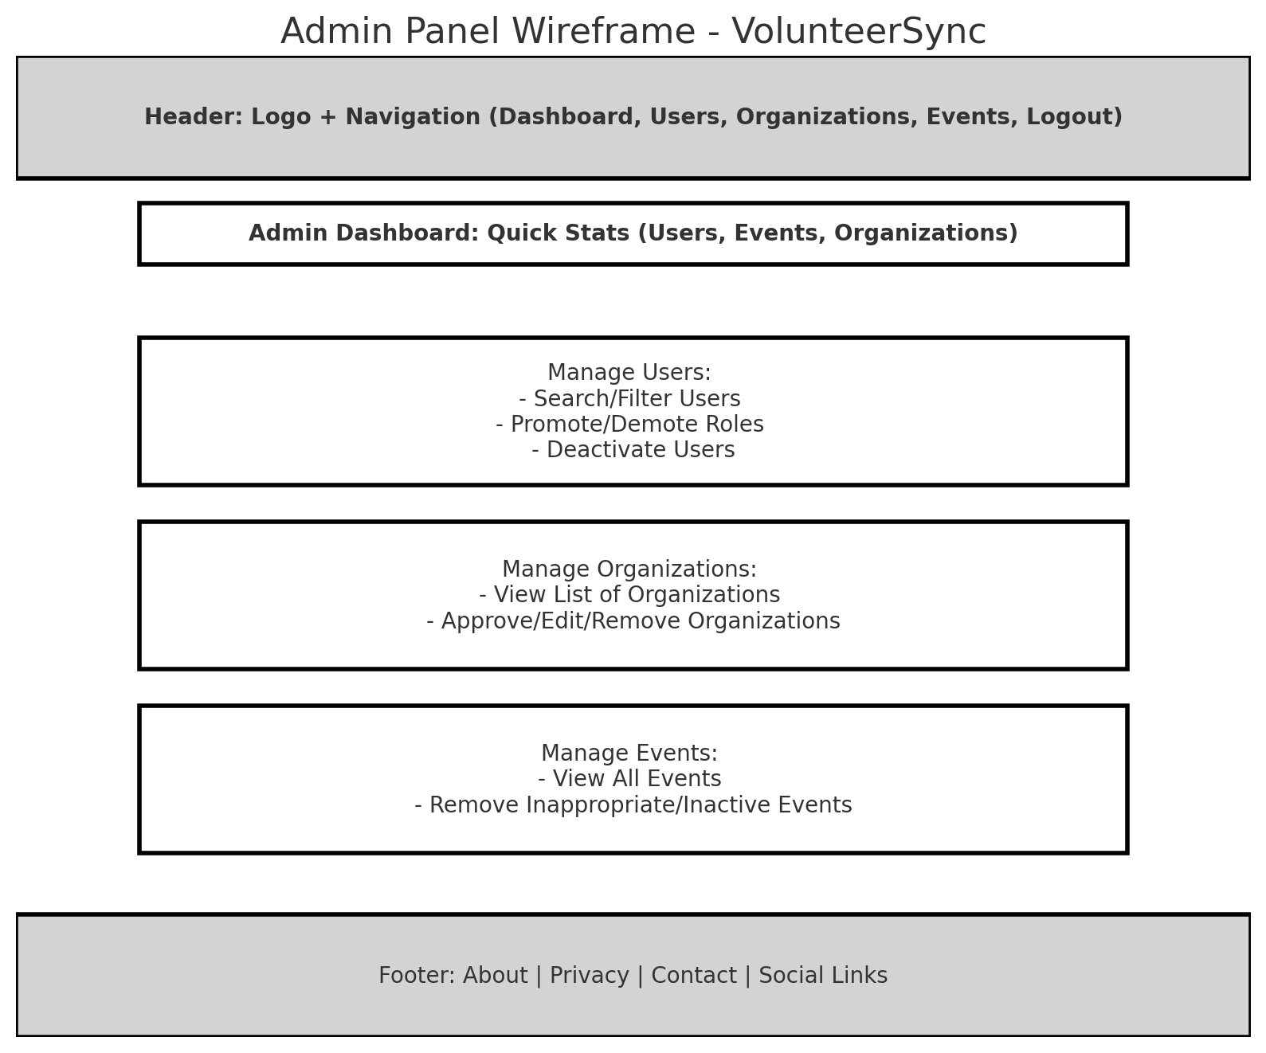

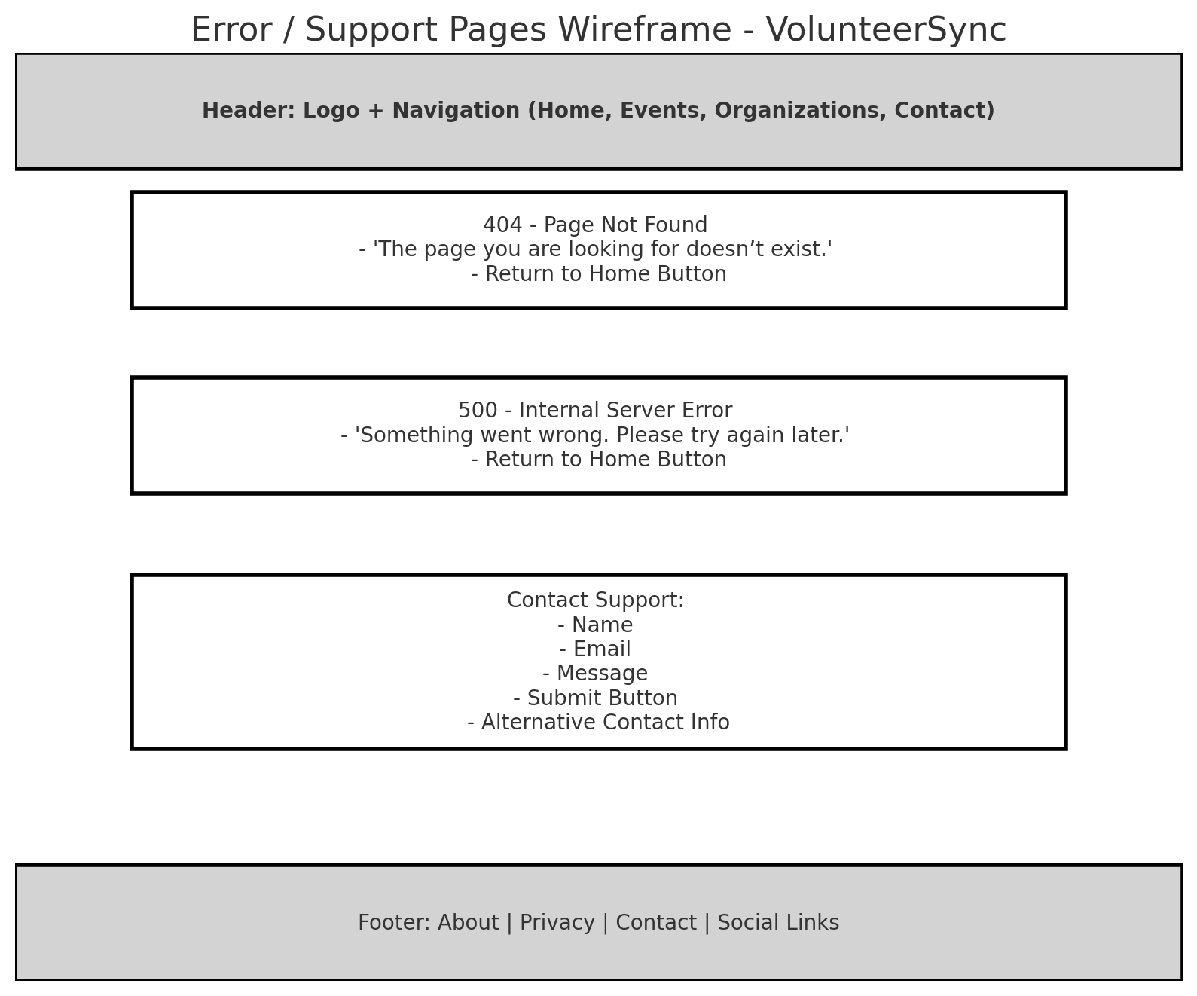

AI-generated mockup UI and Wireframe concepts for VolunteerSync home page (used for visual inspiration, not final design)
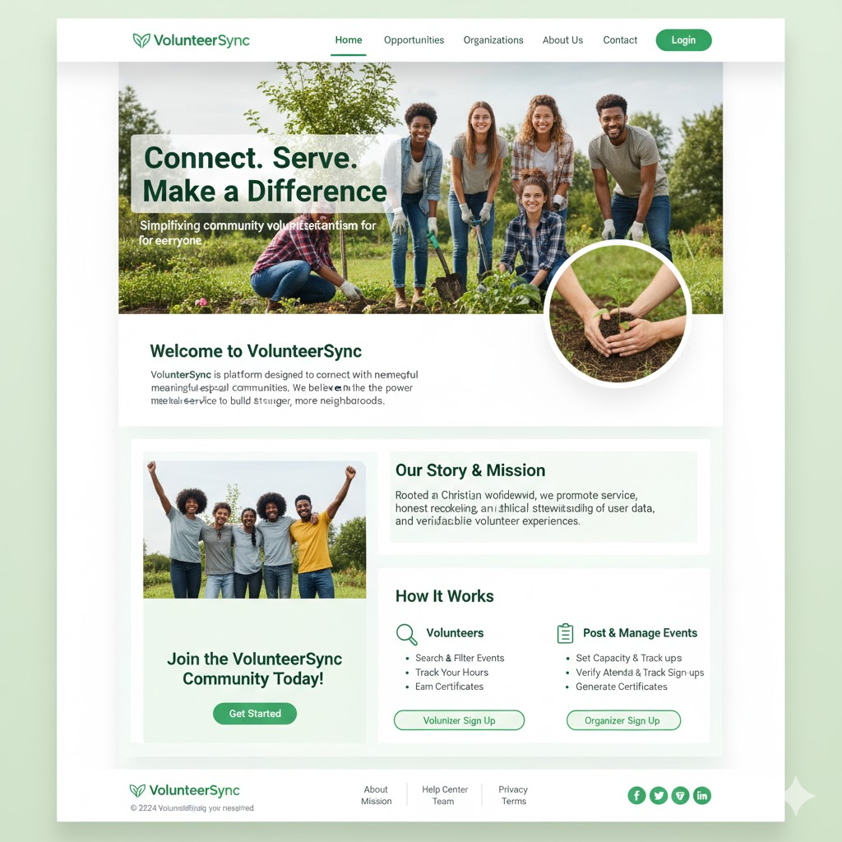
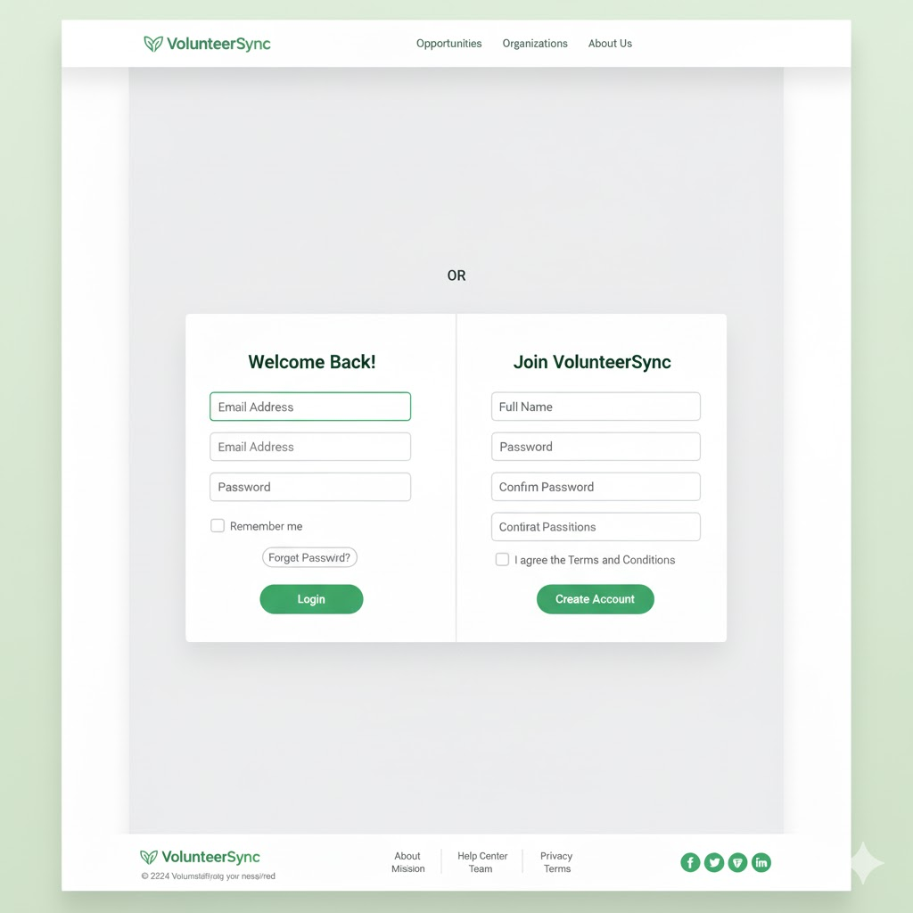
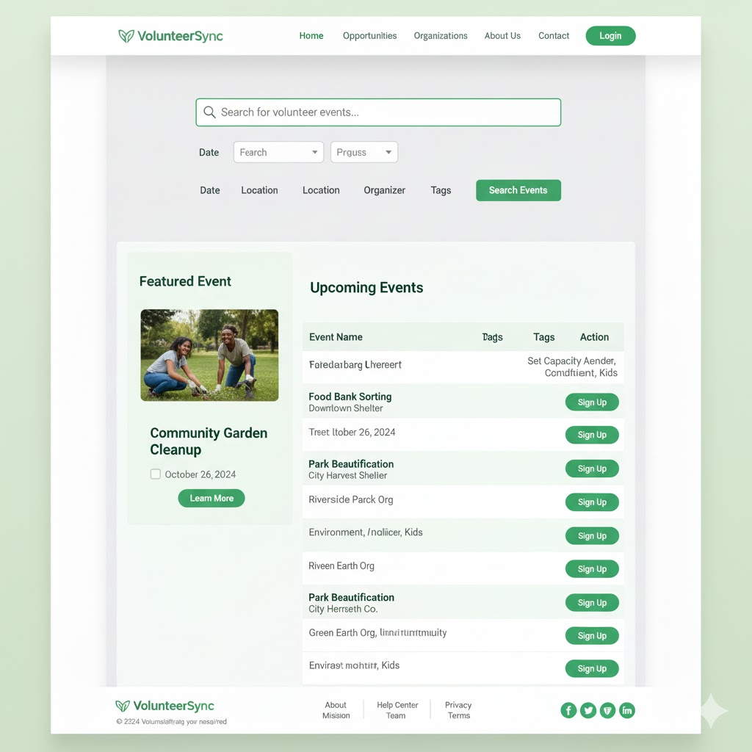
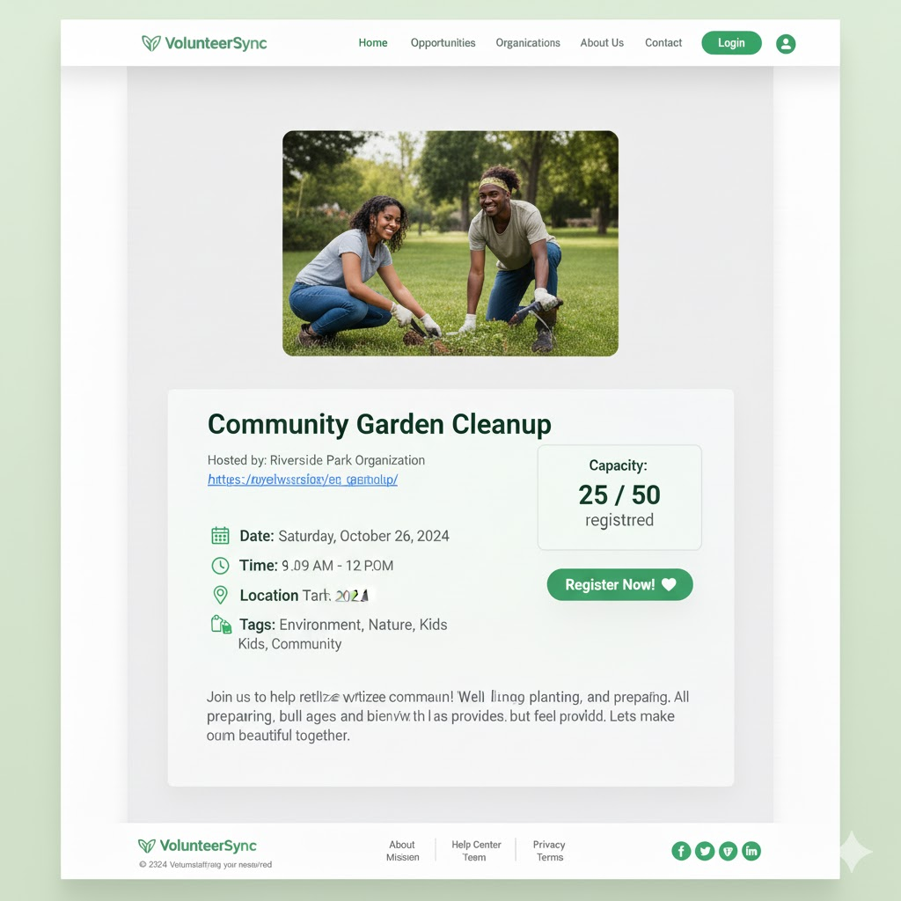
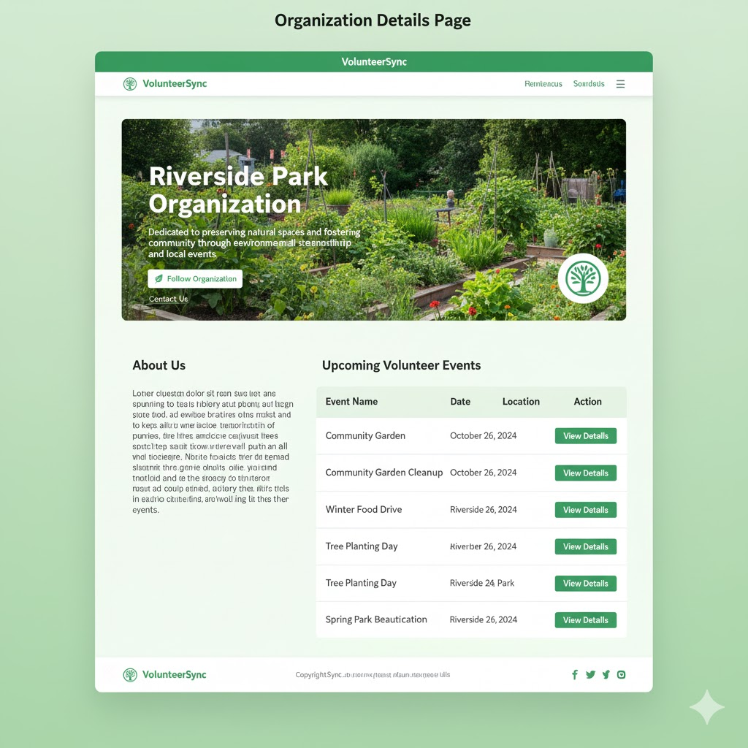

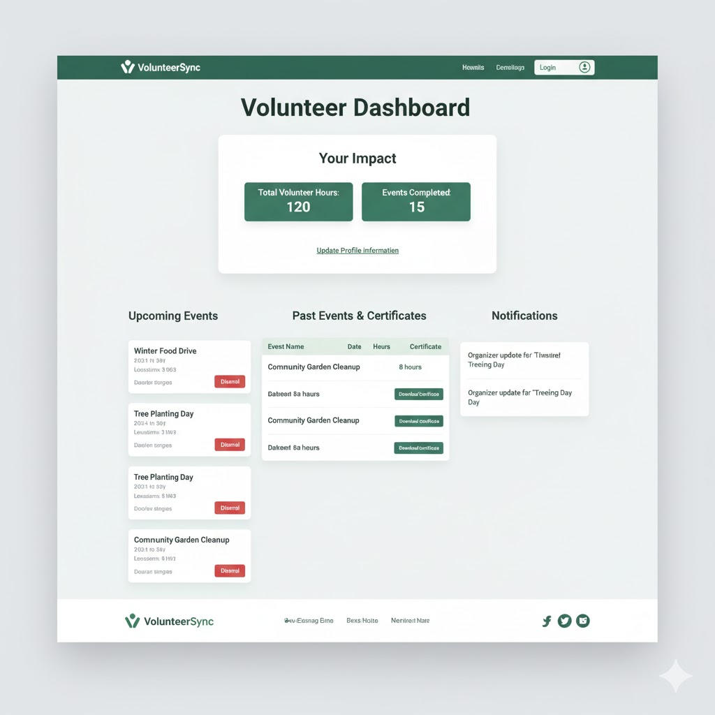
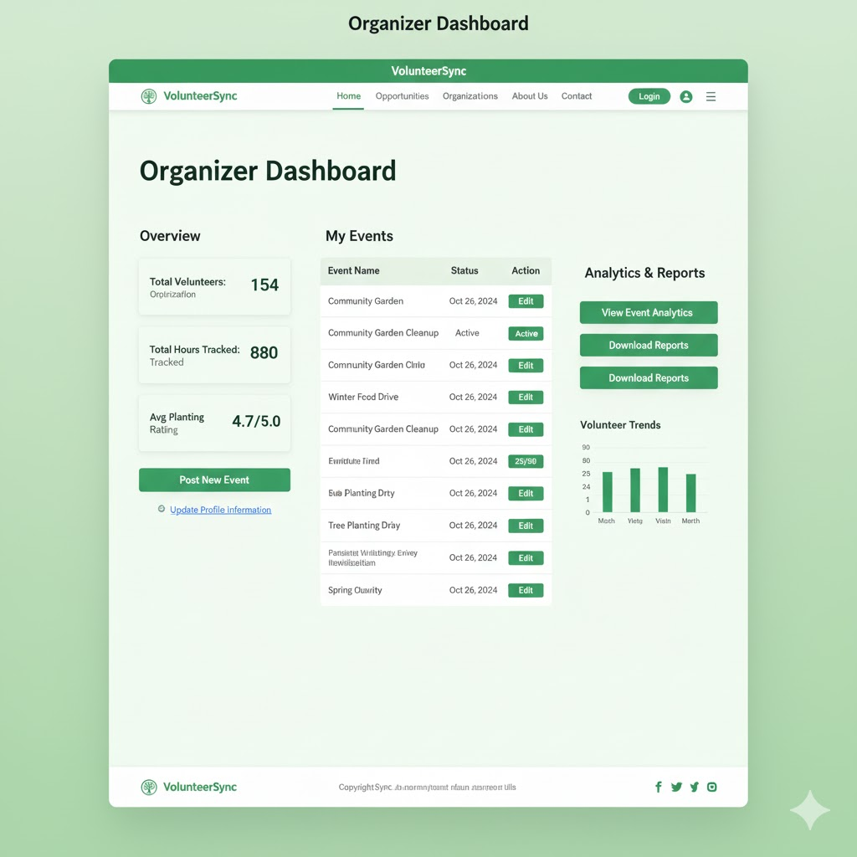
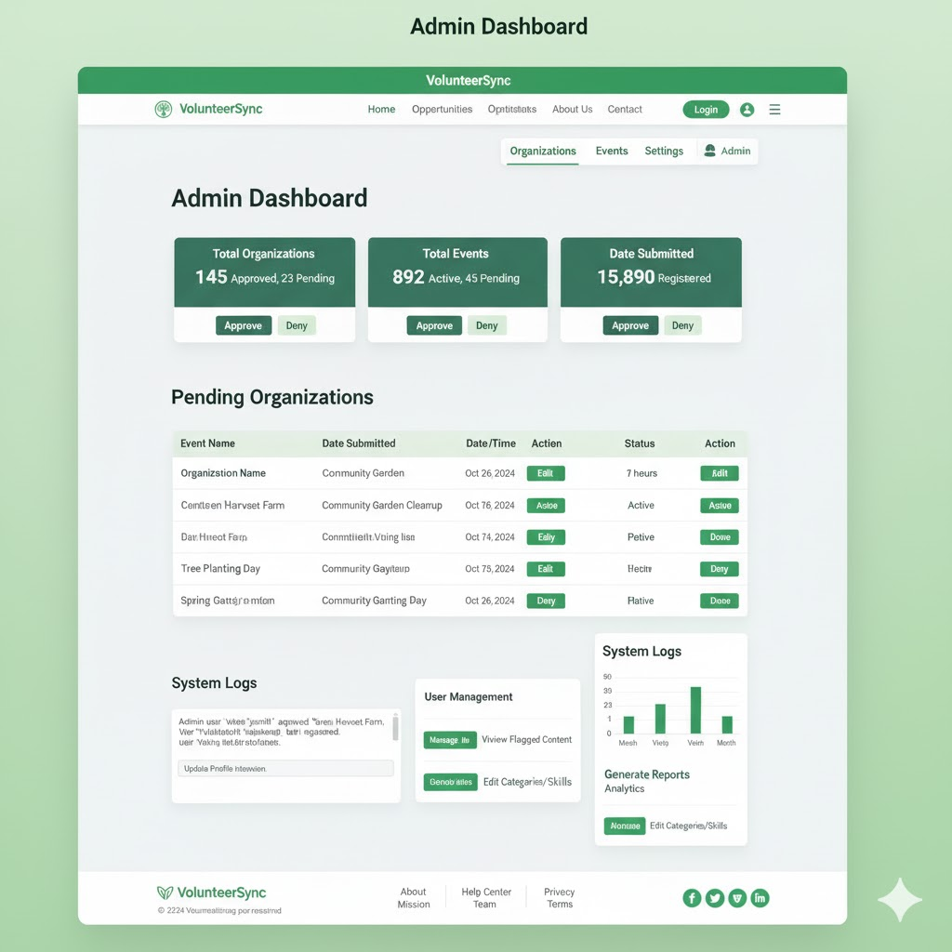

UML Diagrams:
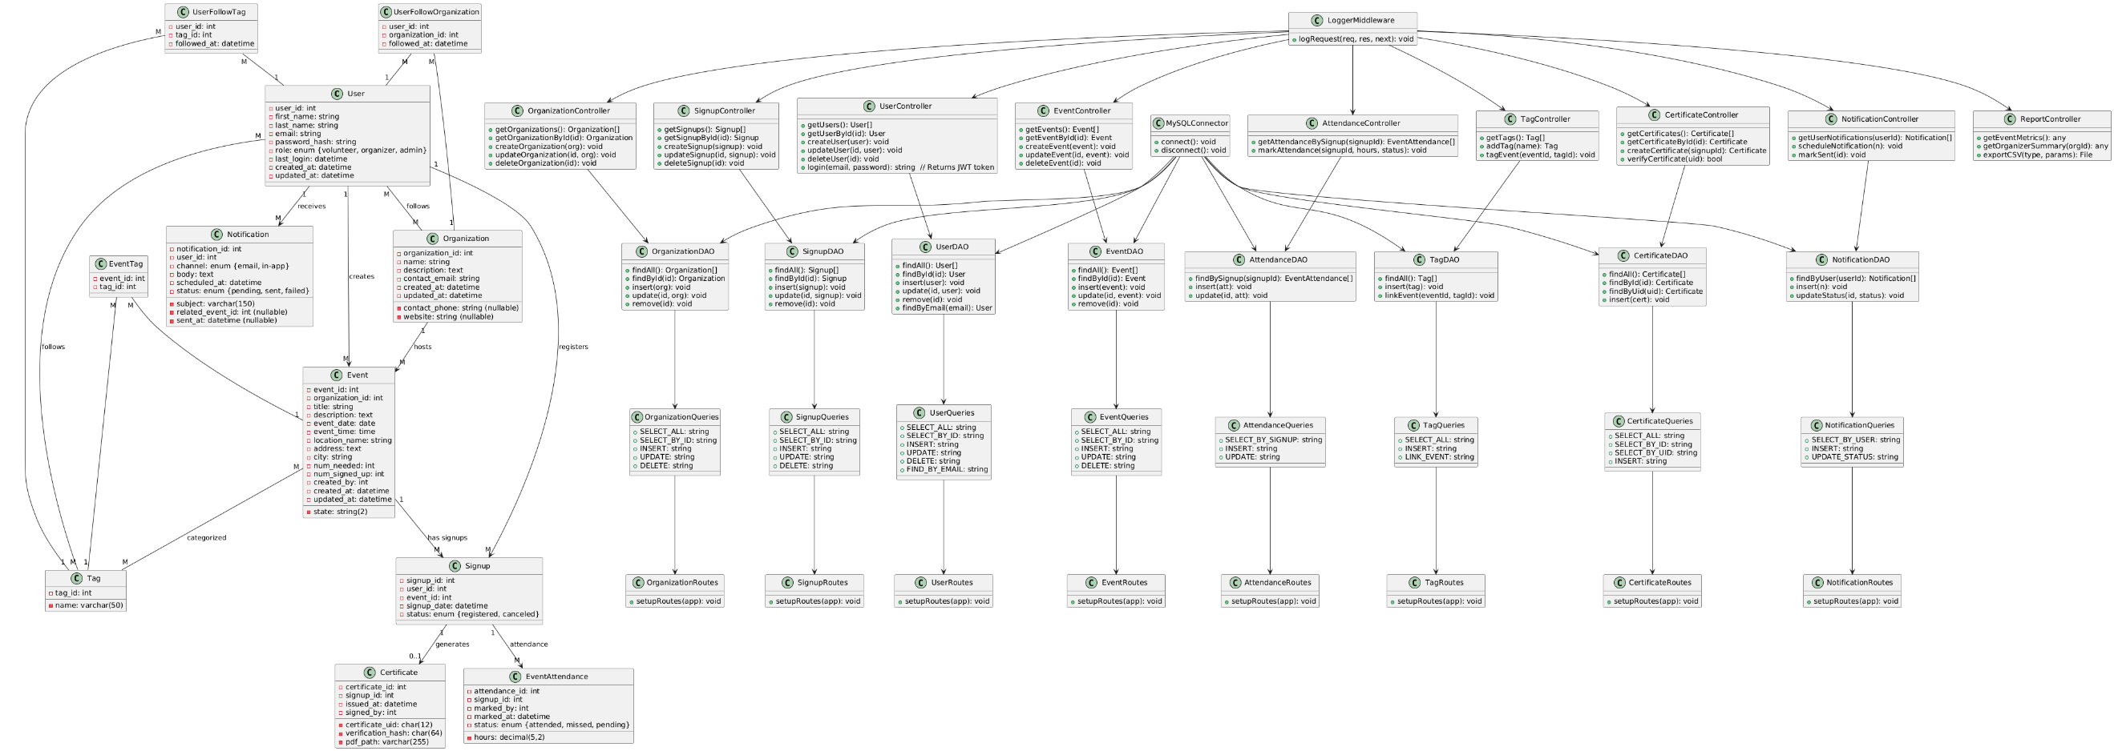

Service API Design:

External services consumed
- SMTP (dev): MailHog on localhost:1025 via SMTP. Used by the API to send reminders and certificate emails. No HTTP API or PII retention.
- Email (future prod option): Amazon SES or SendGrid via SMTP or HTTPS SDK. Same payload as dev, but with provider credentials and throttling.
- File system / object storage: Local folder for generated PDFs in dev. S3 in prod. Files are written by the API and read back for download.
- No other third-party data APIs are consumed at this time. Geocoding, payments, and SMS are out of scope.

Published REST API (application specific)
Base URL: /api/v1
Auth: JWT Bearer in Authorization: Bearer <token>
Roles: admin, organizer, volunteer. Public verifier does not require auth for certificate checks.
Content type: application/json
Errors (standard envelope):
{ "error": { "code": "VALIDATION_ERROR", "message": "City is required", "details": {"field":"city"} } }

Auth
Method | Route | Description
POST | /auth/login | Issue JWT
POST | /auth/register | Create user (volunteer by default)
GET | /auth/me | Return current user profile

Request example: POST /auth/login
{ "email": "evan@example.com", "password": "Secret123!" }
Response
{ "token": "<jwt>", "user": {"user_id": 42, "role": "organizer", "first_name": "Evan"} }

Users
Method | Route | Role | Description
GET | /users | admin | List users
GET | /users/{id} | admin or owner | Get user
PUT | /users/{id} | admin or owner | Update user
DELETE | /users/{id} | admin | Delete user
POST | /users/{id}/link-organization | admin | Link organizer to org

Organizations
Method | Route | Role | Description
GET | /organizations | any | List orgs
GET | /organizations/{id} | any | Org details
POST | /organizations | organizer | Submit org for approval
PUT | /organizations/{id} | organizer or admin | Update org
DELETE | /organizations/{id} | admin | Delete org

Admin moderation
Method | Route | Role | Description
PUT | /admin/organizations/{id}/approve | admin | Approve org
PUT | /admin/organizations/{id}/reject | admin | Reject with reason

Events
Method | Route | Role | Description
GET | /events | any | List events with filters
GET | /events/{id} | any | Event details
POST | /events | organizer | Create event
PUT | /events/{id} | organizer | Update event
DELETE | /events/{id} | organizer or admin | Remove event

Filters: /events?city=San+Diego&state=CA&date=2025-11-15&orgId=7&tag=food-drive&page=1&size=20
Response example: GET /events
{
"items": [
{
"event_id": 101,
"organization_id": 7,
"title": "Beach Cleanup",
"event_date": "2025-11-15",
"event_time": "09:00:00",
"city": "San Diego",
"state": "CA",
"num_needed": 20,
"num_signed_up": 12,
"tags": ["environment","outdoors"]
}
],
"page": 1, "size": 20, "total": 36
}

Tags and follows
Method | Route | Role | Description
GET | /tags | any | List tags
POST | /tags | admin | Create tag
POST | /users/{id}/follows/tags/{tagId} | owner | Follow a tag
DELETE | /users/{id}/follows/tags/{tagId} | owner | Unfollow a tag
POST | /users/{id}/follows/organizations/{orgId} | owner | Follow org
DELETE | /users/{id}/follows/organizations/{orgId} | owner | Unfollow org

Signups
Method | Route | Role | Description
GET | /signups | admin | List all signups
GET | /users/{id}/signups | owner or admin | User’s signups
POST | /signups | volunteer | Register for event
DELETE | /signups/{signup_id} | volunteer or admin | Cancel signup

Request example: POST /signups
{ "event_id": 101 }

Attendance and certificates
Method | Route | Role | Description
POST | /events/{id}/attendance | organizer | Mark attendance with hours
POST | /certificates | organizer | Issue certificate for a signup
GET | /certificates/{id} | owner or admin | Download certificate PDF
GET | /verify/{certificate_uid} | public | Verify certificate authenticity

Request example: POST /events/{id}/attendance
{ "signup_id": 555, "attended": true, "hours": 3.5 }
Response example: POST /certificates
{
"certificate_id": 9001,
"certificate_uid": "VS-8F3D-A92C",
"issued_at": "2025-11-20T18:22:00Z",
"pdf_url": "/api/v1/certificates/9001/download"
}

Notifications
Method | Route | Role | Description
POST | /notifications/test | admin | Send test email to a user
POST | /notifications/schedule | admin | Schedule event reminder job

Notification payload
{
"user_id": 42,
"channel": "email",
"subject": "Event Reminder",
"body": "See you Saturday at 9am.",
"scheduled_at": "2025-11-14T17:00:00Z"
}

Reports and metrics
Method | Route | Role | Description
GET | /reports/dashboard?range=last90&orgId=7 | admin or organizer | Rollup metrics
GET | /reports/events/fill-rate?range=last30 | admin or organizer | Fill rate by event
GET | /reports/attendance/hours?range=year | admin or organizer | Hours by month

Response example: GET /reports/dashboard
{
"range": "last90",
"orgId": 7,
"eventFillRate": 0.78,
"attendanceHours": [
{"month": "2025-08", "hours": 120.5},
{"month": "2025-09", "hours": 148.0}
],
"activeVolunteers": 214
}

Access details for third-party integrations
- SMTP (dev MailHog): host localhost, port 1025, no TLS, no auth.
JSON template to email layer:
- { "to": "volunteer@example.com", "subject": "Thanks for helping", "html": "<p>Great job!</p>" }
- Email (prod option):
  - SES: HTTPS or SMTP with IAM creds. Respect provider rate limits.
  - SendGrid: HTTPS /v3/mail/send with API key in Authorization: Bearer <key>. Request body mirrors the same to/subject/html payload above.

Notes
- All create/update routes validate input and return 400 on failures.
- Role checks are enforced in route guards.
- Public verification is read only and returns 404 for unknown or revoked IDs.
- A full OpenAPI/Swagger file can be exported later from controllers, but this section covers the endpoints and JSON shapes expected by a third-party developer.

NFR’s (Security Design, etc.):

The Non-Functional Requirements for VolunteerSync focus on making sure the platform stays fast, secure, maintainable, and reliable as it grows. Based on the feedback from Milestone 2, I expanded the NFR set to include more detail around exception handling, graceful failure recovery, stronger observability, and ethical data handling. These additions strengthen the system’s long-term sustainability and trustworthiness, especially as reporting, certificate verification, and cloud scalability become part of the expanded scope. The new NFRs help ensure consistent behavior under load, predictable error messaging, privacy protection, and support for future enhancements without creating risk to stability.

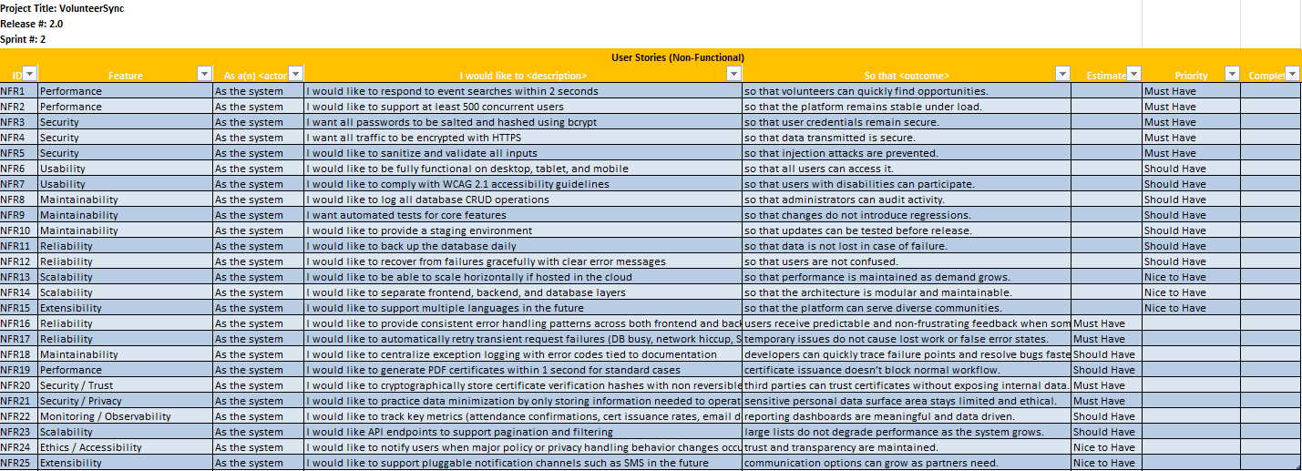

Operational Support Design:

VolunteerSync will support monitoring and logging through structured application logs, request tracing, and health checks. The backend API will use Winston for structured JSON logs and Morgan for HTTP access logging. Each request will include a unique request_id so that errors can be traced end to end. Audit logging will be added for privileged actions like role changes, certificate issuance, and organization approvals. Sensitive fields (passwords, tokens) will be redacted before writing to logs.
For exceptions, the system will use a global Express error handler that returns clean, user friendly error codes while still writing full technical details to the server logs. This supports easier debugging without confusing the user.
After deployment, system logs, error rates, and slow queries will be monitored to help identify performance issues. In local development, logs will be stored locally and alerted manually. If deployed to cloud later, logs can be shipped to a monitoring service (CloudWatch) and performance can be tracked with simple SLO targets, such as event search under 2 seconds and API availability above 99.5 percent.
This level of operational support helps ensure stability, quick issue diagnosis, and improved reliability as the system scales.

Other Documentation:

The following supporting diagrams have already been included in the design sections above and are provided as supplemental design artifacts to support the architectural approach:
- VolunteerSync Sitemap Navigation Diagram
- Logical Solution Architecture Diagram
- Physical Deployment Architecture (Local Dev + Future Cloud Option)
- ERD generated from MySQL Workbench after expanded schema updates
These items visually reinforce system navigation, service boundaries, deployment considerations, and data structure alignment for the expanded scope.
No additional storyboards or mockups are necessary at this stage because the UI layout and flows are already defined throughout this milestone.

Appendix A – Technical Issue and Risk Log
- Use the template to identify and monitor project issues and risks.
Issues and Risk Log
Issue or Risk | Description | Project Impact | Action Plan/Resolution | Owner | Importance | Date Entered | Date to Review | Date Resolved
R | Performance risk if advanced search filtering queries become slow once database grows with real usage | Could increase response times over 2 seconds and impact performance NFR | Use indexed fields, EXPLAIN query checks during development, and performance testing early with seeded Mockaroo data | Evan Wilson | High | 3 | Milestone 4 | TBD
  Milestone
R | Cloud deployment readiness delay if AWS hosting option takes longer than expected to configure | Could impact planned scalability deliverable at end of CST-452 | Prioritize Local Dev deployment first, keep cloud env optional until after core features stable | Evan Wilson | Medium | 3 | Milestone 4 | TBD
  Milestone
R | PDF certificate formatting inconsistencies between local dev and future cloud file storage | Could delay certification feature and verification use case | Lock PDF template early, run POC testing in both dev + sample S3 environment before final integration | Evan Wilson | Medium | 3 | Milestone 4 | TBD
  Milestone

Appendix B – References
Project Documentation References:
Wilson, E. (2025). Evan Wilson CST-451_452 Sprint Backlog Milestone 4 [Unpublished internal course document].
Wilson, E. (2025). Evan Wilson Milestone 3 CST-451 Data Dictionary [Unpublished internal course document].
Wilson, E. (2025). VolunteerSync Logical Architecture Diagram [Unpublished system design diagram].
Wilson, E. (2025). VolunteerSync Physical Deployment Diagram [Unpublished system design diagram].

External Tools Used in Documentation
draw.io. (2025). Diagramming workspace platform. Retrieved from https://www.draw.io/
Google. (2025). Gemini 2.5 Flash Image (Model Name: Nano Banana; Accessed October 12, 2025) [Generative AI image model]. Google
PlantText. (2025). PlantUML text-based class diagram generator. Retrieved from https://www.planttext.com/
Lucidchart. (2025). Cloud-based UML and process diagramming tool. Retrieved from https://www.lucidchart.com/

Academic Source Referenced
Cobb, C. G. (2021). The project manager’s guide to mastering agile: Principles and practices for an adaptive approach (2nd ed.). Wiley.
Appendix C – External Resources
GIT URL: | Project Portfolio: https://github.com/ewilson87/VolunteerSync  Back-end API: https://github.com/ewilson87/VolunteerSync-API/tree/main  Front-end Angular: https://github.com/ewilson87/VolunteerSync-Angular-Frontend/tree/main
Screencast URL: | YouTube VolunteerSync Playlist (All Milestones): https://www.youtube.com/playlist?list=PLsicDUNz539oU69jqgdwGfWyBzUrsYafJ  Milestone 3 (November 23rd, 2025): https://youtu.be/A95dBOsipZ4  Milestone 4 (January 11th, 2026): https://youtu.be/_47rNvOhEIY  Milestone 5 (January 25th, 2026): https://youtu.be/TtyhlmYfZcg  Milestone 6 (February 3rd, 2026): https://youtu.be/KInZfGMCeVM
Hosting URL: | NA at this time

